***Use this word document to provide your opinion***

**Problem 1:**

Perform the following Steps

1. <https://docs.aws.amazon.com/athena/latest/ug/getting-started.html>
2. <https://docs.aws.amazon.com/athena/latest/ug/work-with-data.html>
3. <https://docs.aws.amazon.com/athena/latest/ug/querying-athena-tables.html>

**Total points: 100**

**a.**

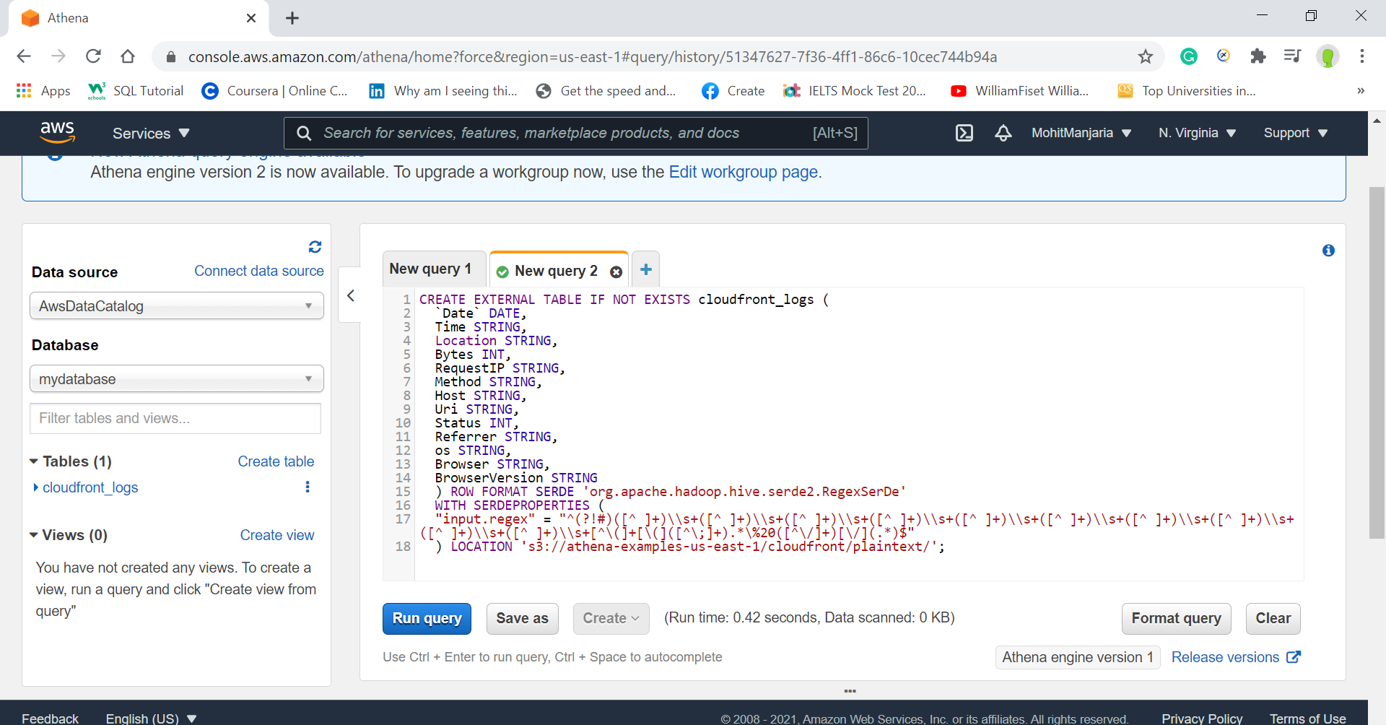

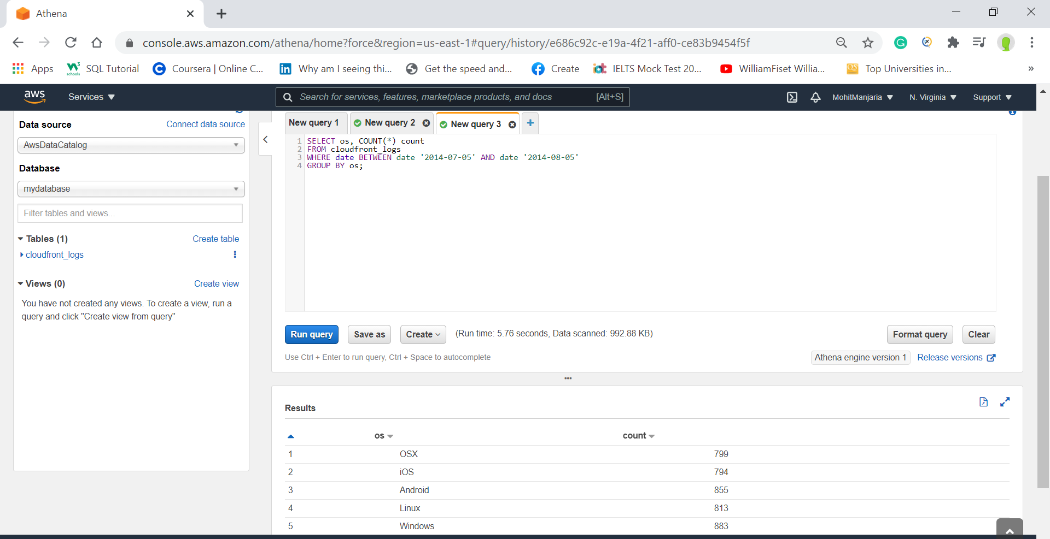

------------------------------------------------------------------------------------------------------------

Upload your MS Word document named: **ITC6460**_YourLastNameYourFirstNameHWXX.docx to the course web site in your folder for Assignment 1. Note: Do NOT include your JPEG files as separate files.

If you have issues with the upload, please notify your instructor! If you are raising issues that might be of interest to all of your colleagues in the class, please use the Discussion Board, Assignment XX thread on the course site. The Discussion Board is your best friend.